**Heating Processes**

**Heat:**

Is the energy that is in the process of being transferred from on place to another due to a temperature difference.

**Kinetic Particle Model:**

We use it to explain the states of matter, and changes between state

-According to the kinetic particle model, all matter is made up of small particles that are in constant motion.

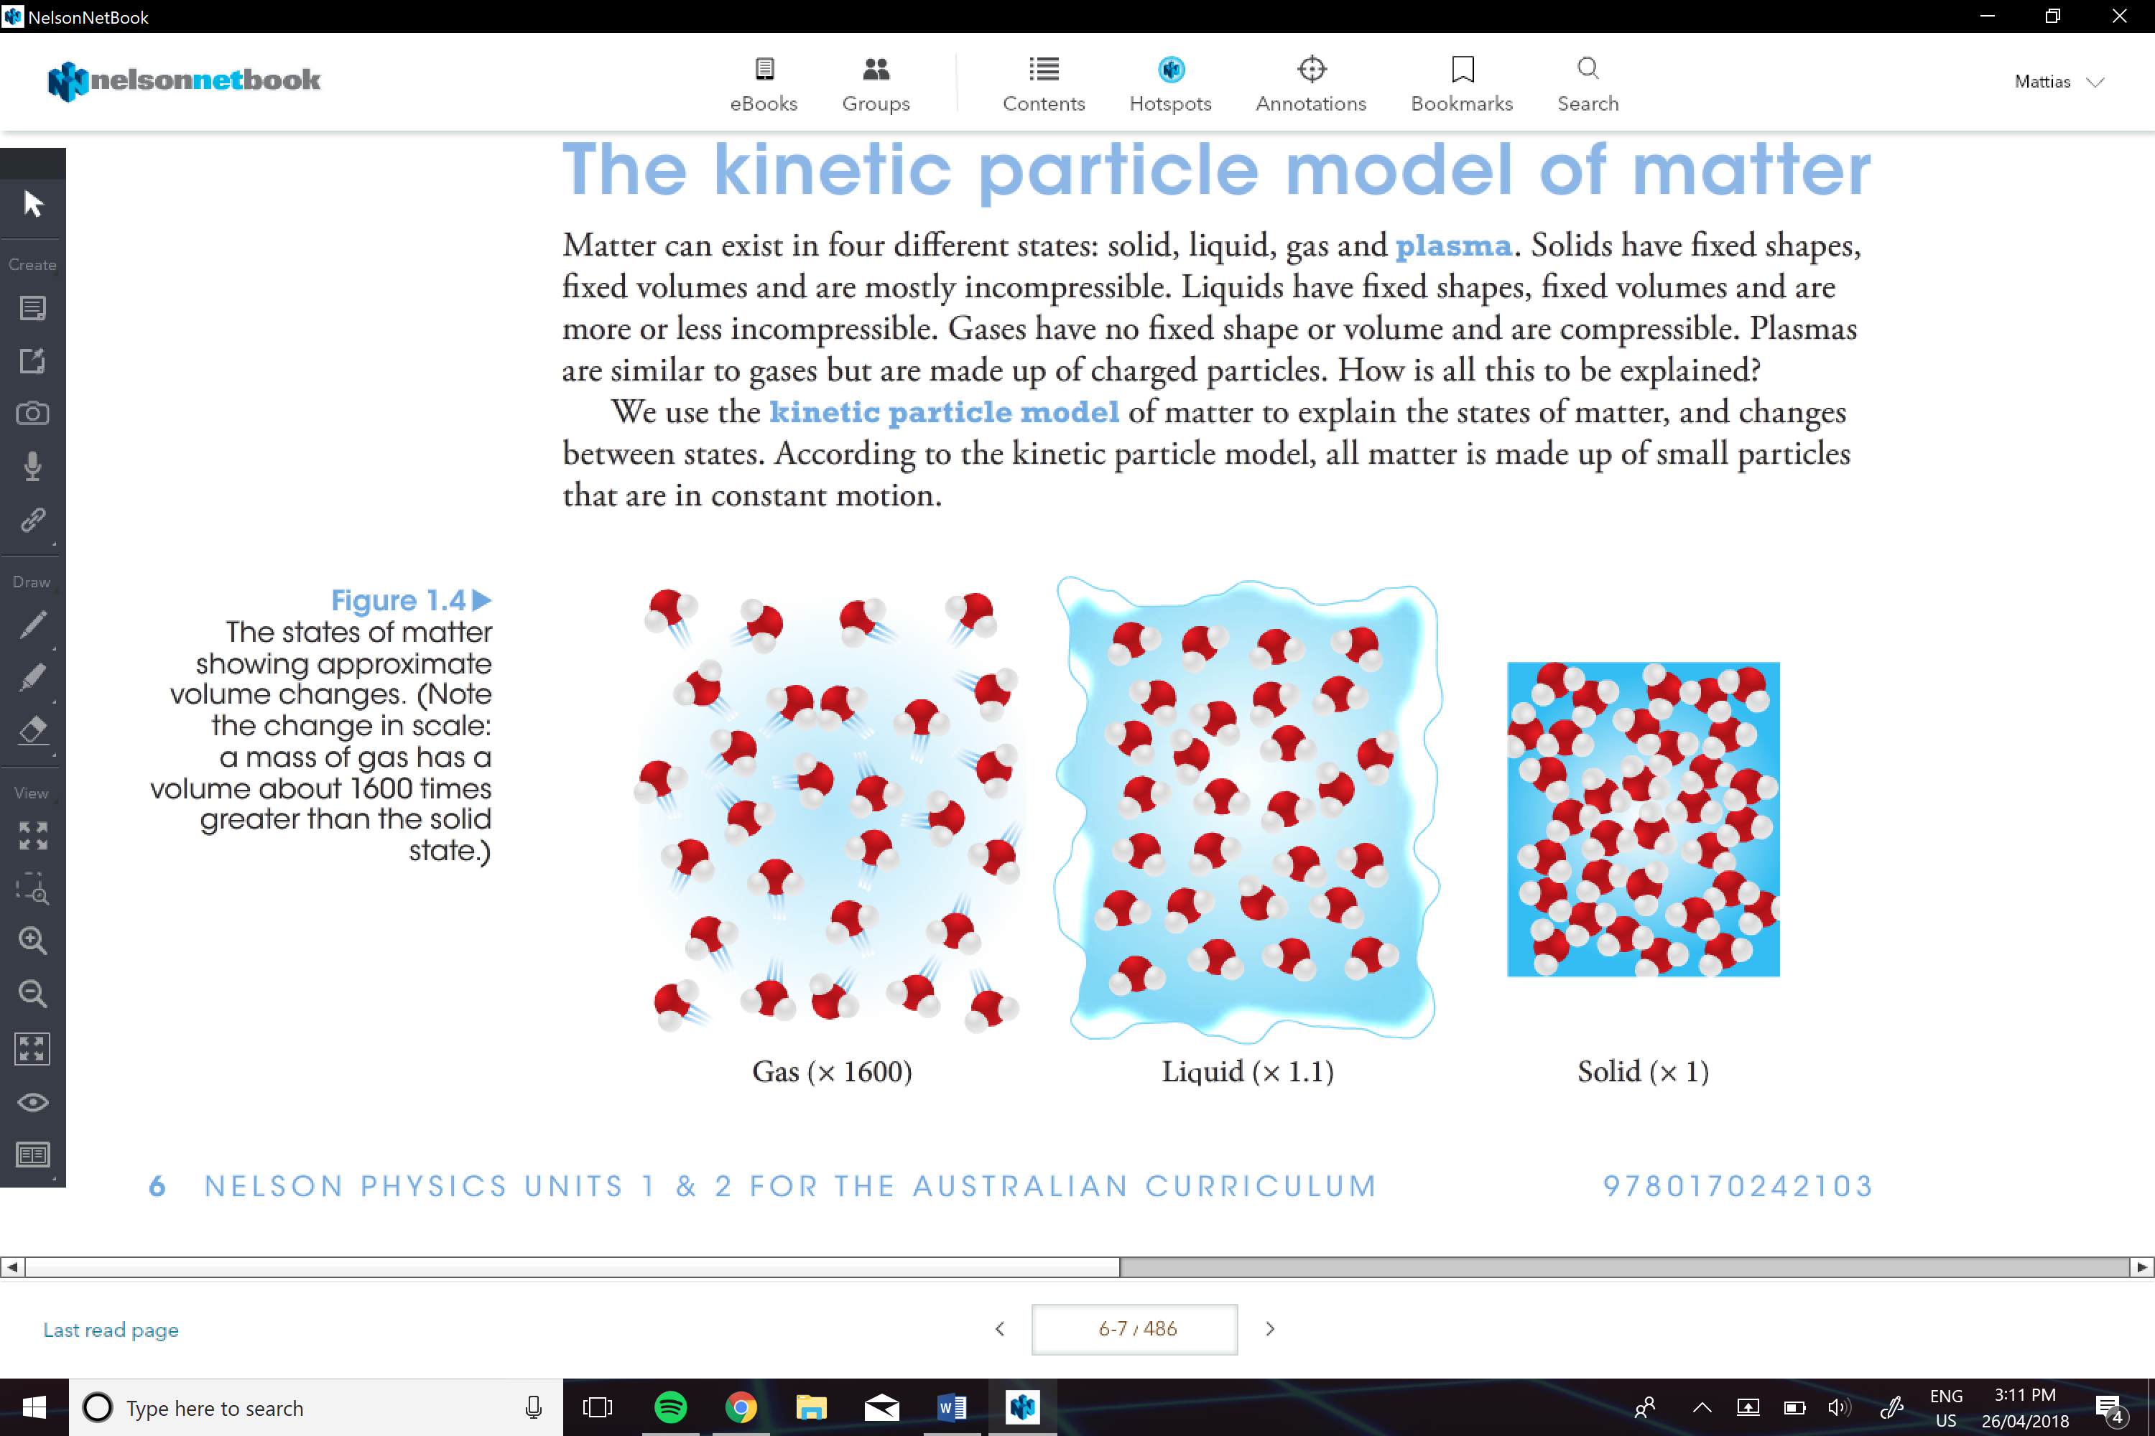

**Assumptions of Kinetic Particle model:**

* All matter is made up of small particle in constant motion; they have kinetic energy
* Collisions between particles are perfectly elastic; the total kinetic energy before and after the collisions is the same
* Potential energy is stored in the ‘springs’ that connect the particles; potential energy depends on the distance between particles

**Potential Energy:**

Energy that is stored in a system due to the configuration and interaction within the system.  
-the particles in a solid, have bonds that behave like springs and this is why **solid material has potential energy**

**Kinetic Energy:**

The energy a body possesses due to its motion, it can be in the form of translational, rotational or vibrational energy.

-in a **solid there is kinetic energy**, due to the atoms are all vibrating and moving about constantly.

**Elastic Collision:** (mostly for gas?)

A collision between two or more objects in which there is no loss of total kinetic energy.

-kinetic energy is transferred from one particle to another but isn’t converted into potential.

**Internal Energy:**

The sum of the kinetic energy of the particles in the system and the potential energy stored in the system.

**Temperature:**

Is a measure of the average kinetic energy of the particles in a body.

**Thermal Equilibrium:**

is the state of a system in which its [heat](http://energyeducation.ca/encyclopedia/Heat) flow is balanced with its surroundings, meaning the [temperatures](http://energyeducation.ca/encyclopedia/Temperature) of the system and surroundings are the same. A system at a higher temperature will [transfer heat](http://energyeducation.ca/encyclopedia/Heat_transfer) to a system at a lower temperature when they are in contact, until their temperatures are equal.

-when two substances at different temperatures are mixed, the heat lost by one is equal to the heat gained by the other.

**Specific Heat Capacity:**

Is the amount of energy required to increase the temperature of one kilogram by one kelvin without a change of state

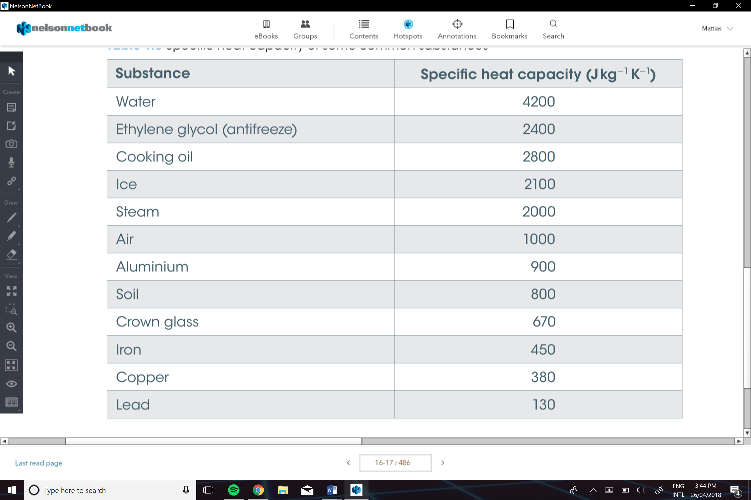

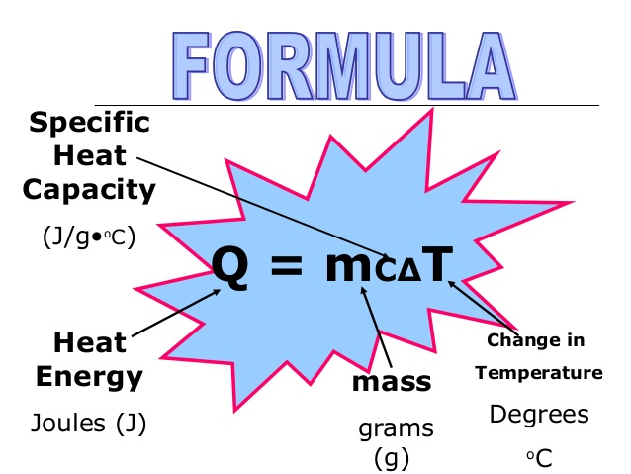

e.g

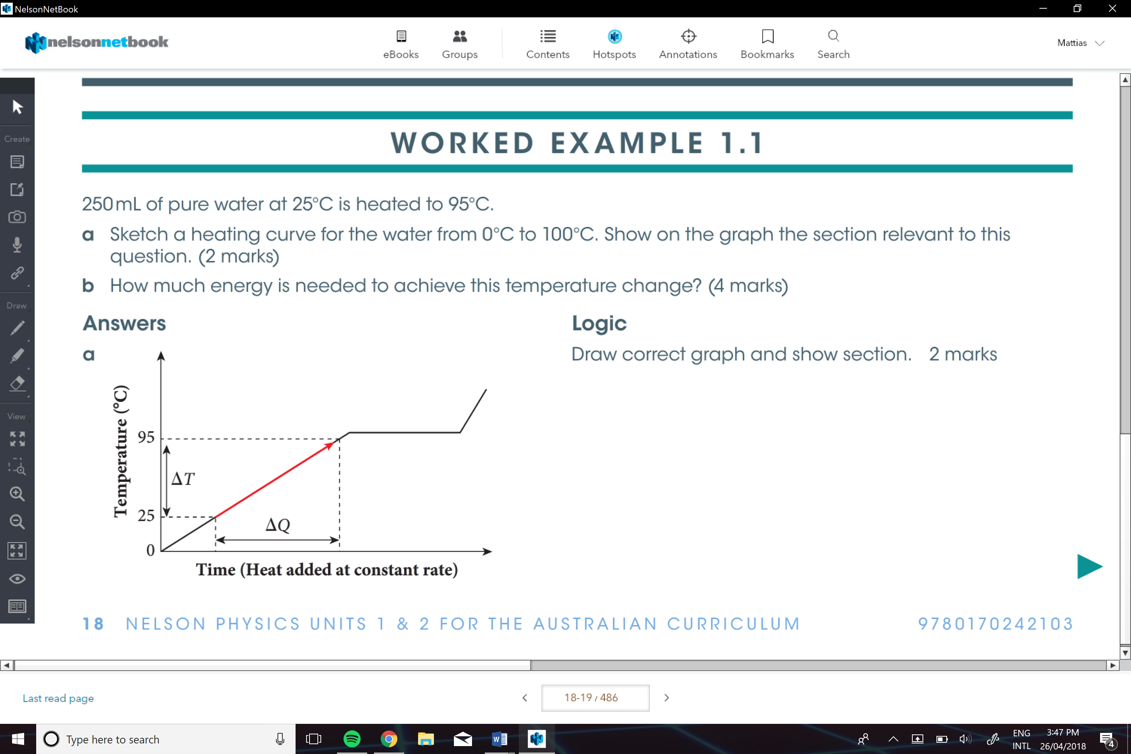

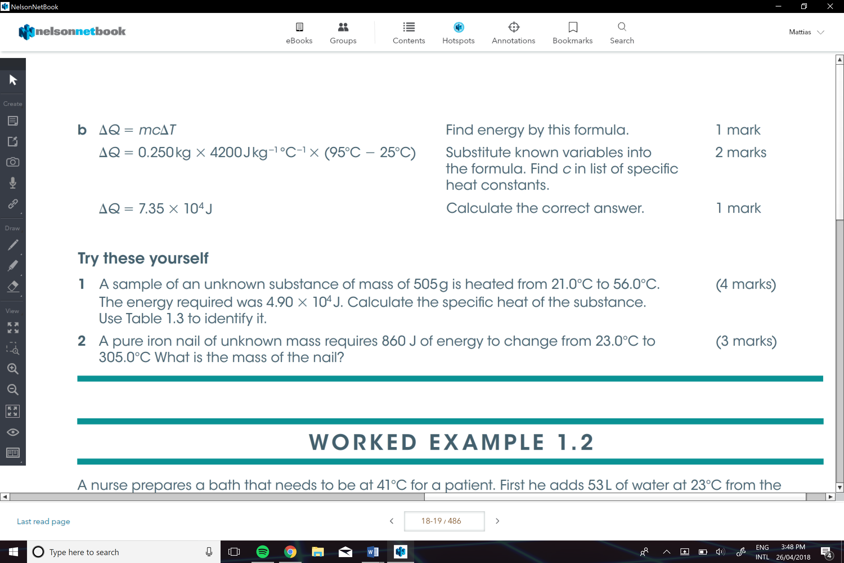

**make sure u write the assumptions.

**Law of Conservation Of energy:**

In an isolated system, energy can neither be created nor destroyed. Energy can be transferred or transformed but the total energy of an isolated system remains constant. The total change in energy is zero.

**Isolated System:**

Is a system in which no energy or matter can enter or leave.

**State Changes and Latent Heat And Power**

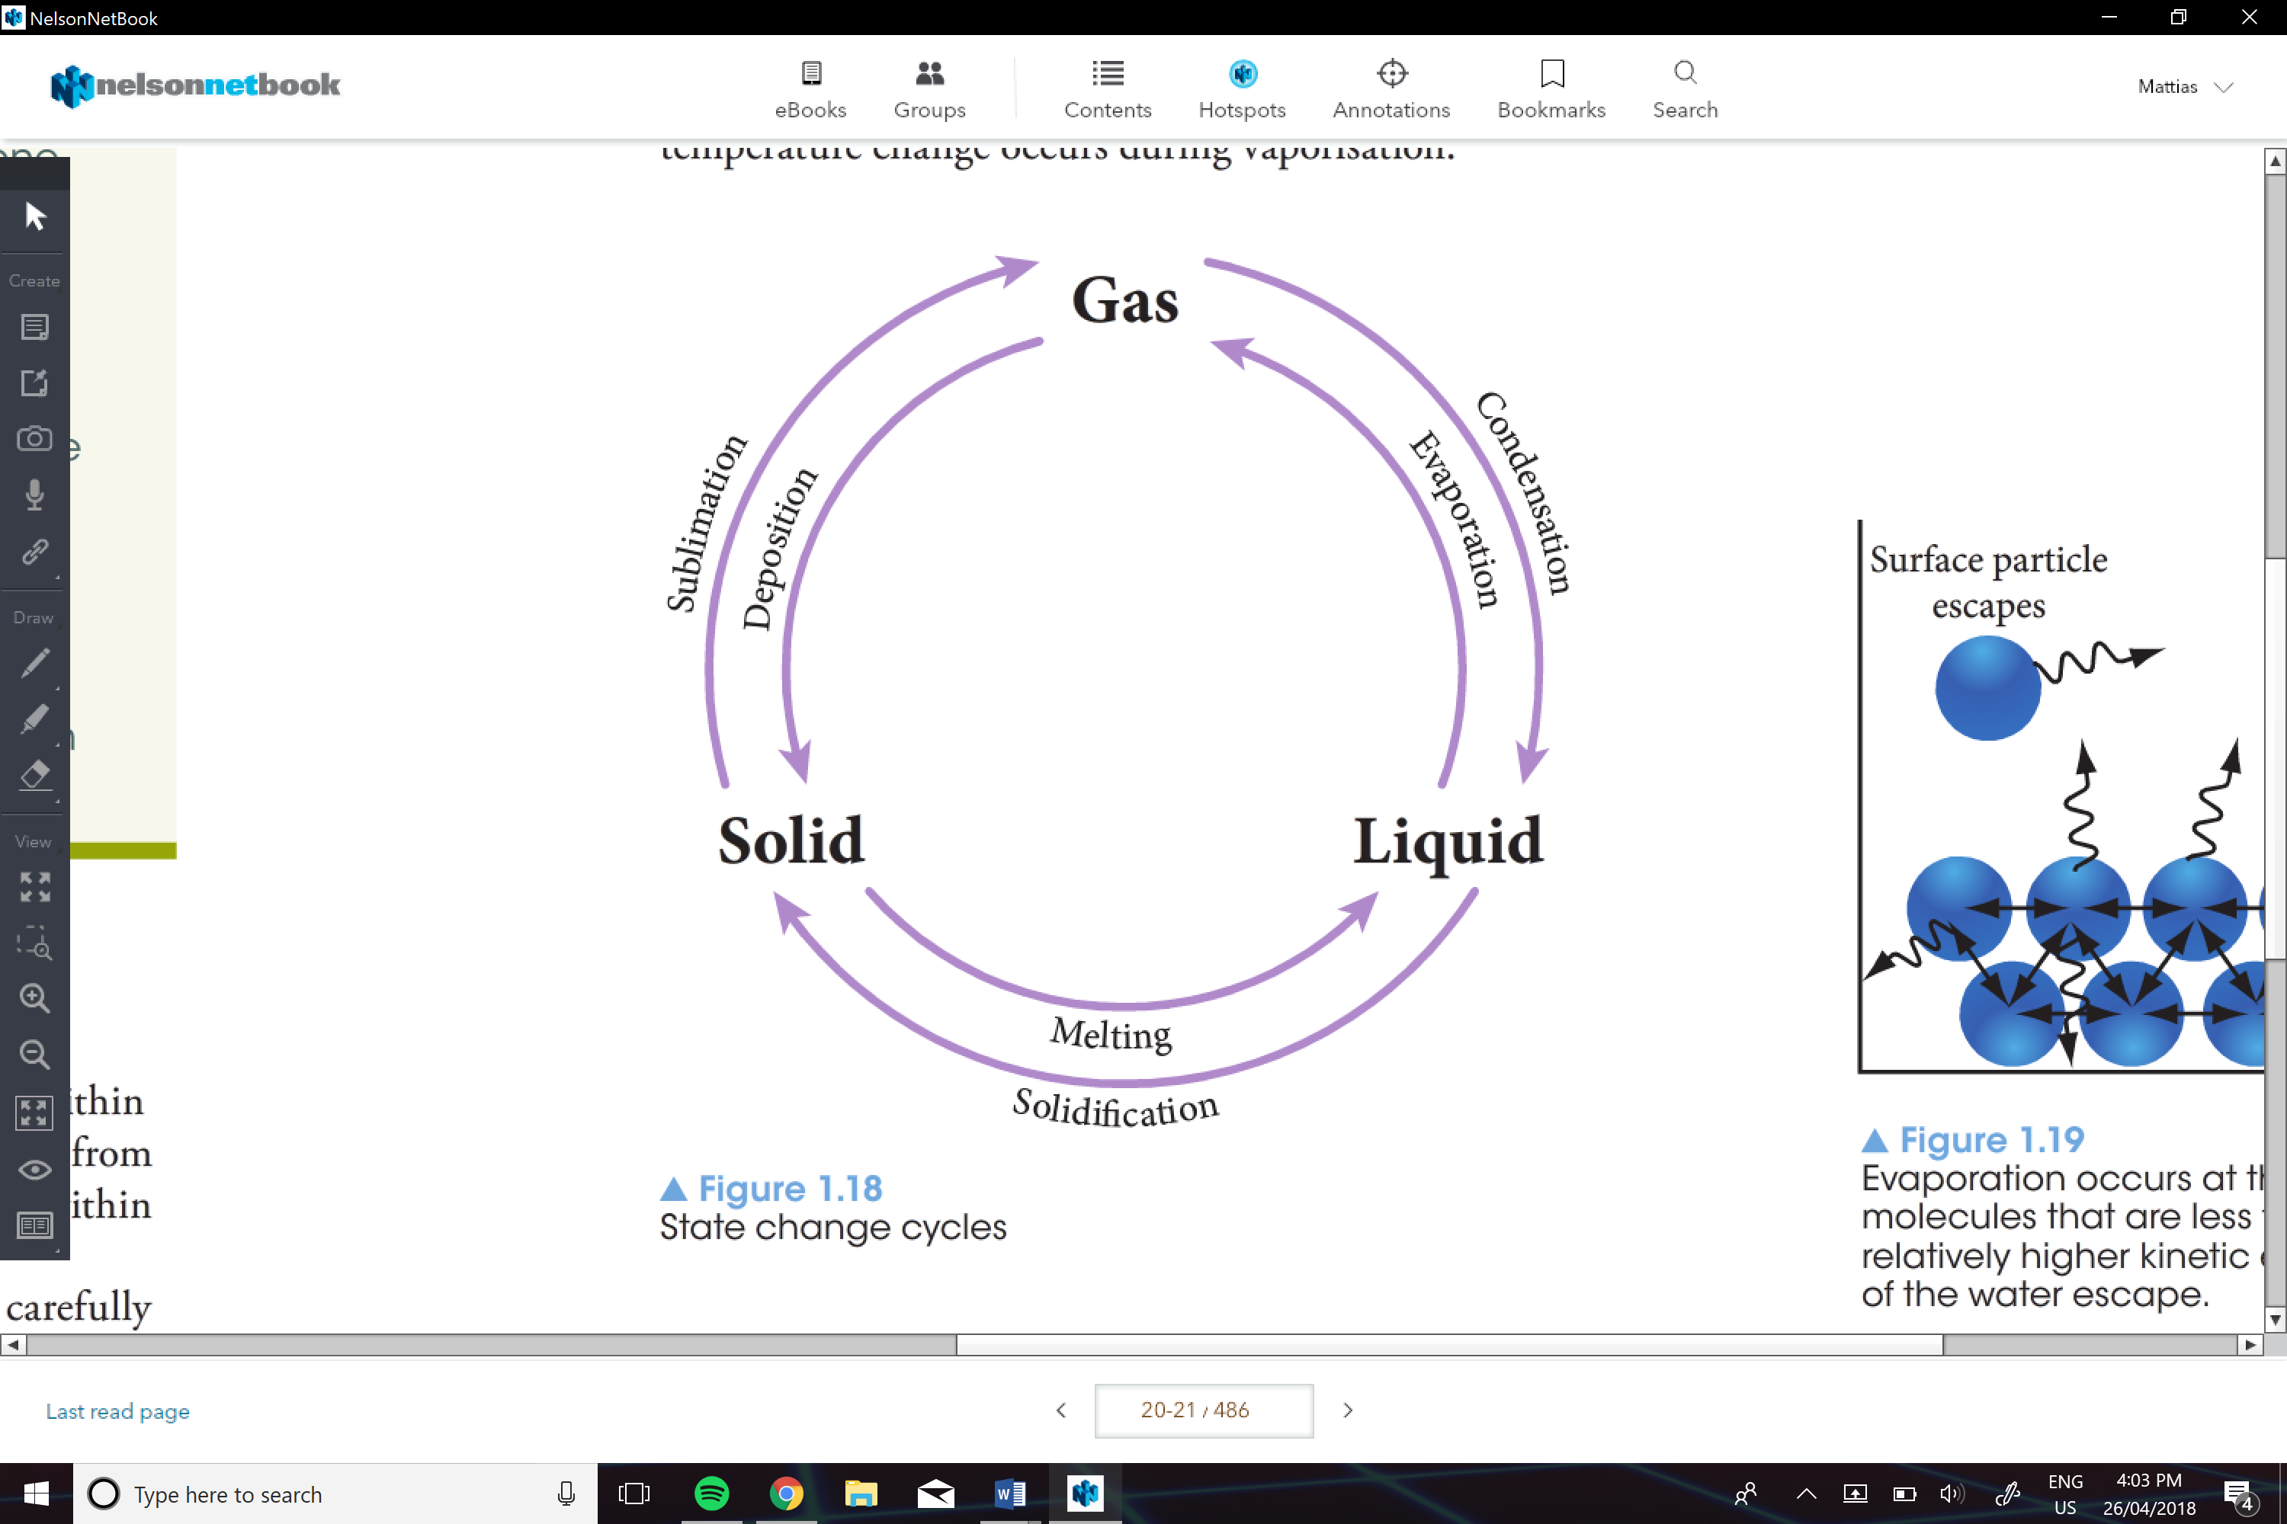

**Latent Heat:**

The heat required to change the state of a substance at its melting or boiling point without a change in temperature.

**The specific Latent Heat of Fusion:**

Is the energy required to change the state of 1Kg of the substance from its solid form to its liquid form.

**The specific Latent Heat of Vaporisation:**

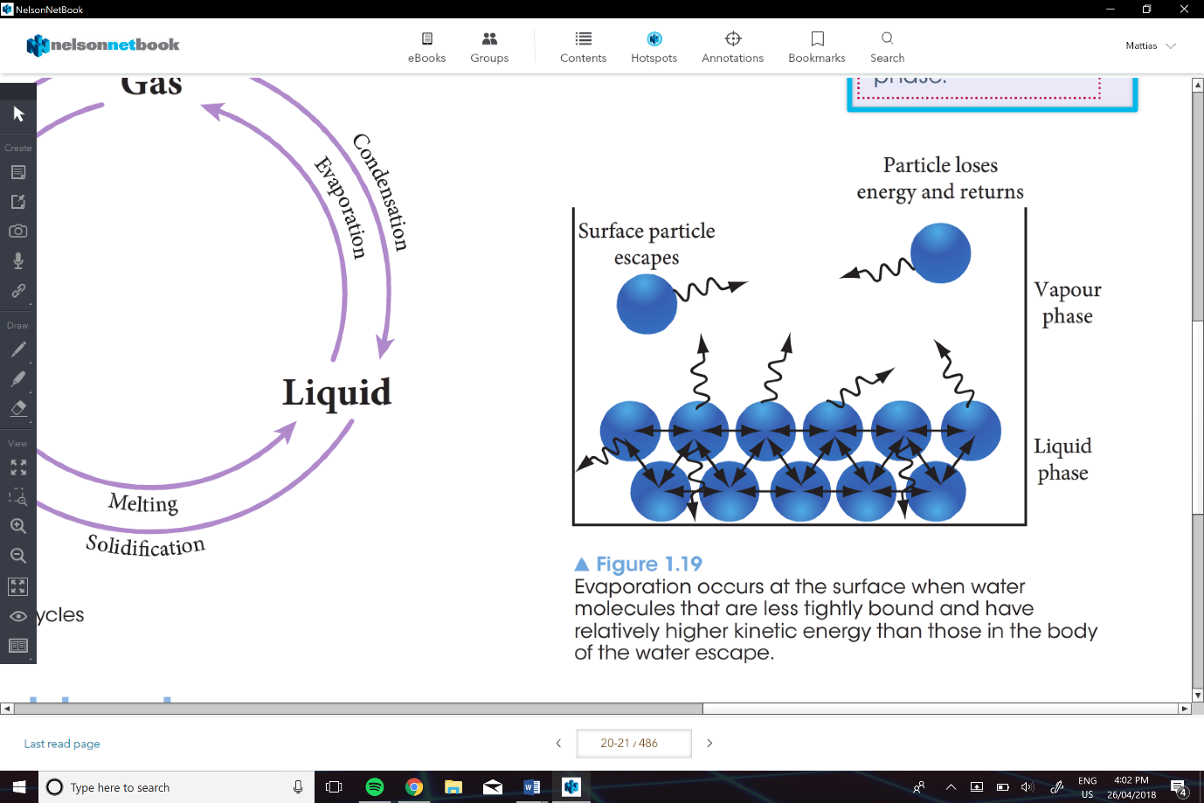Is the heat required to change the state of 1kg of the substance from its liquid to gaseous stae.

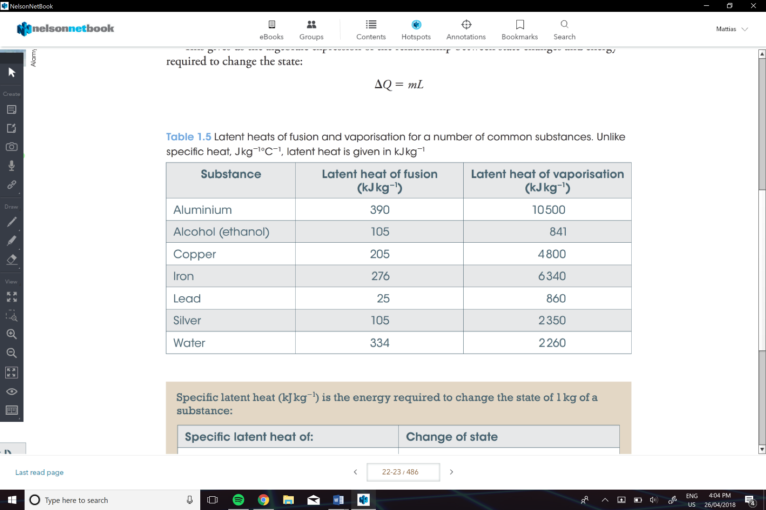

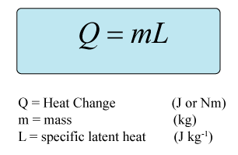

Example of calculations that have change of state:

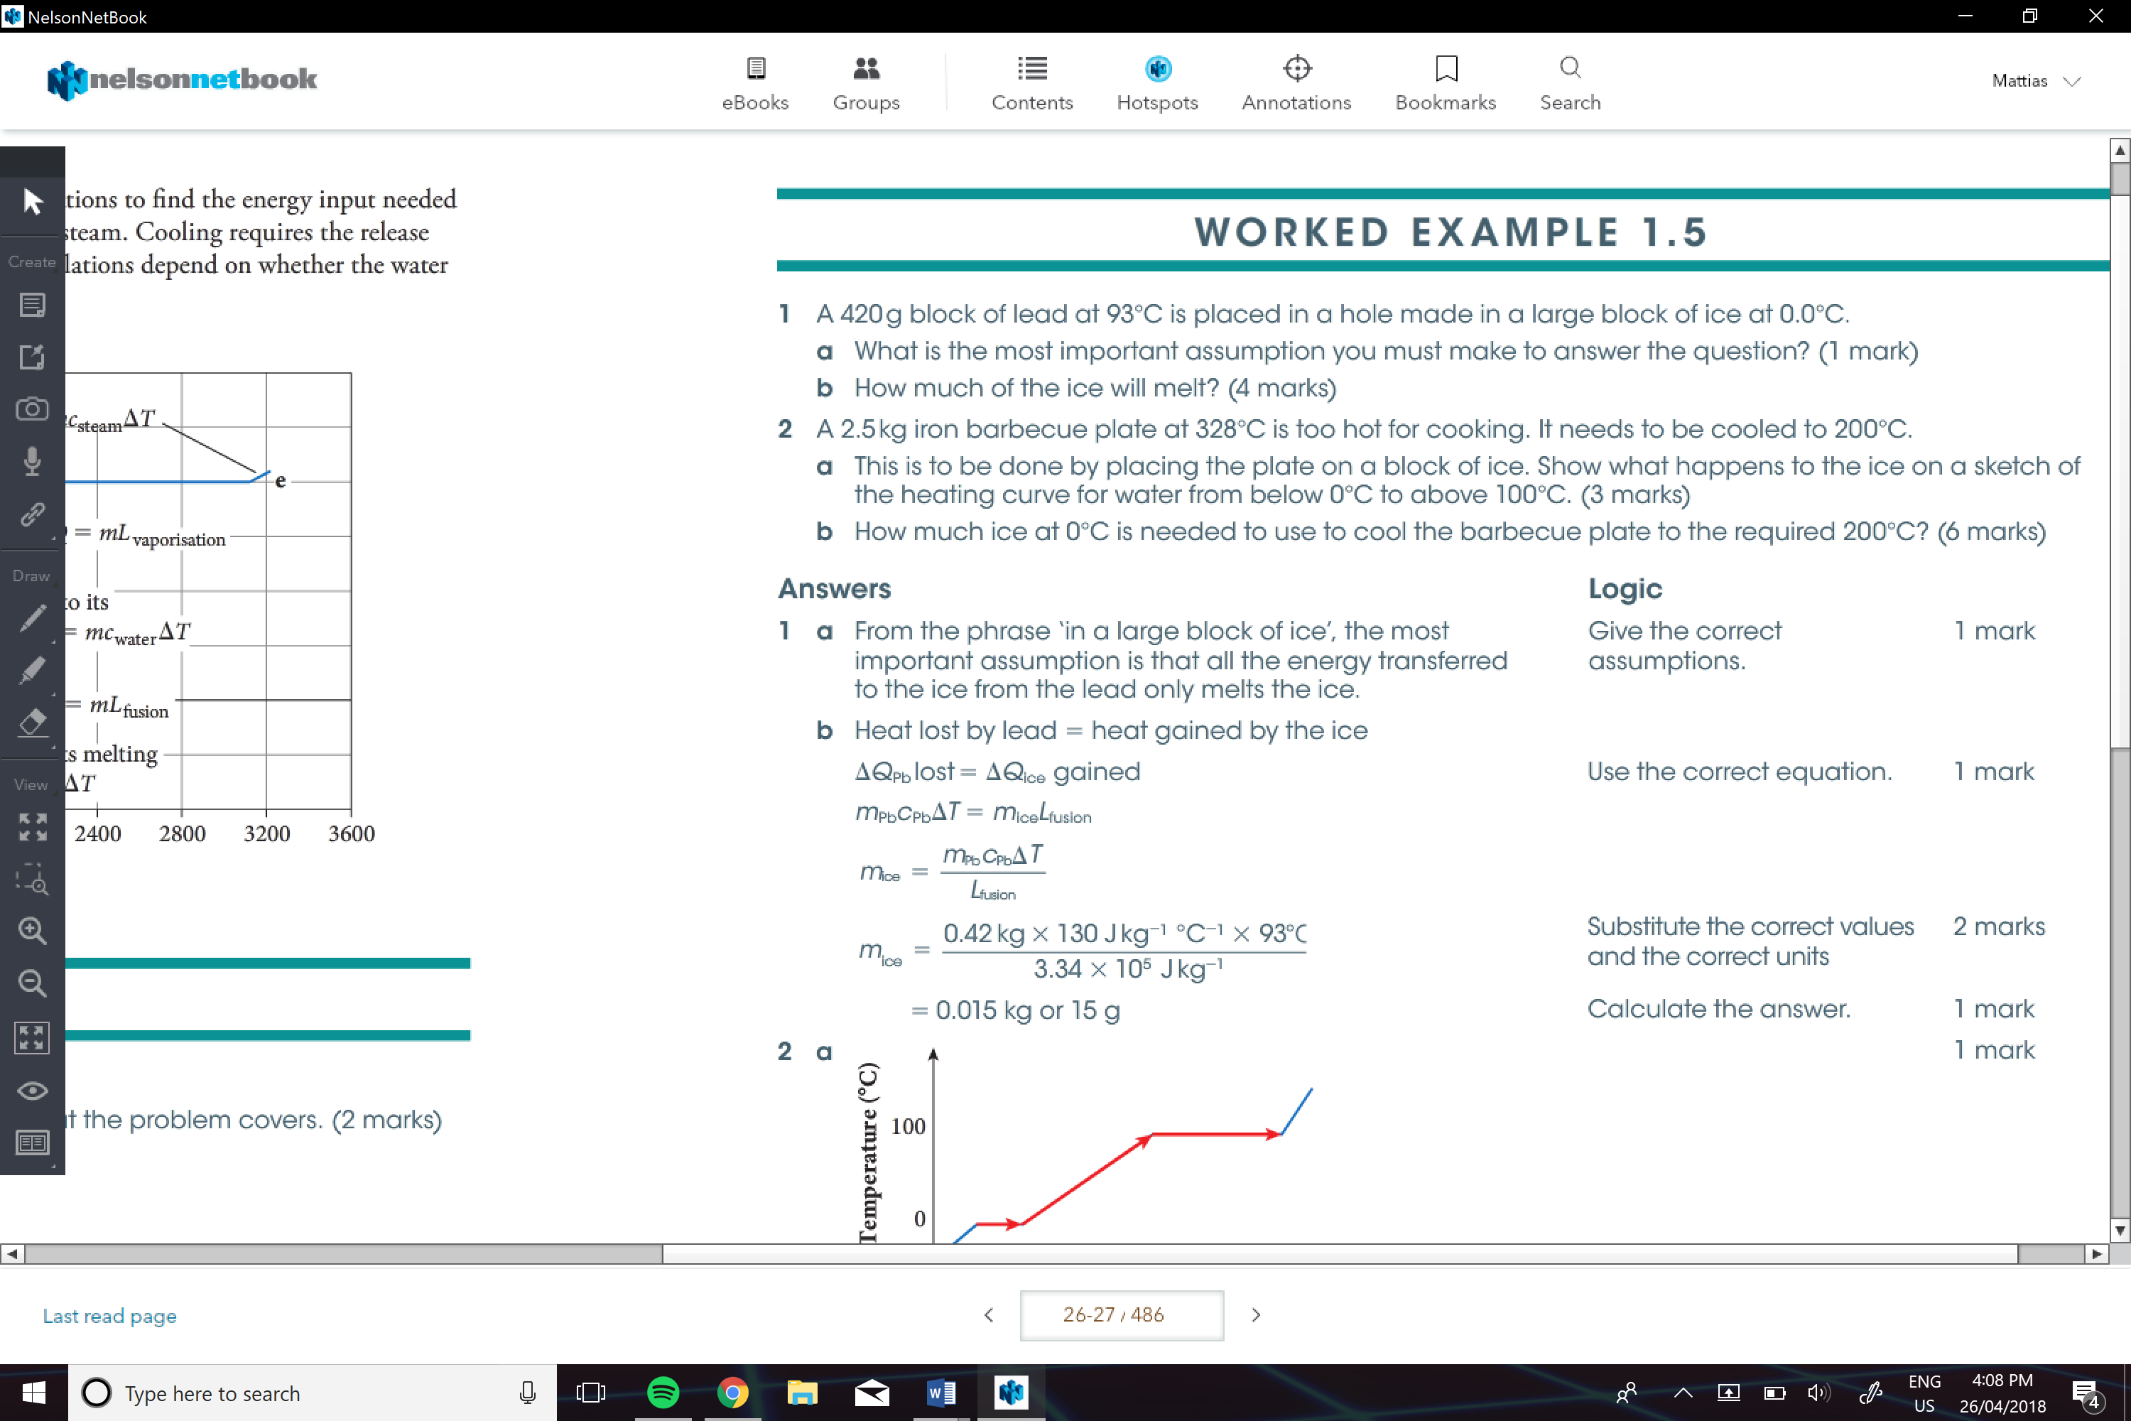

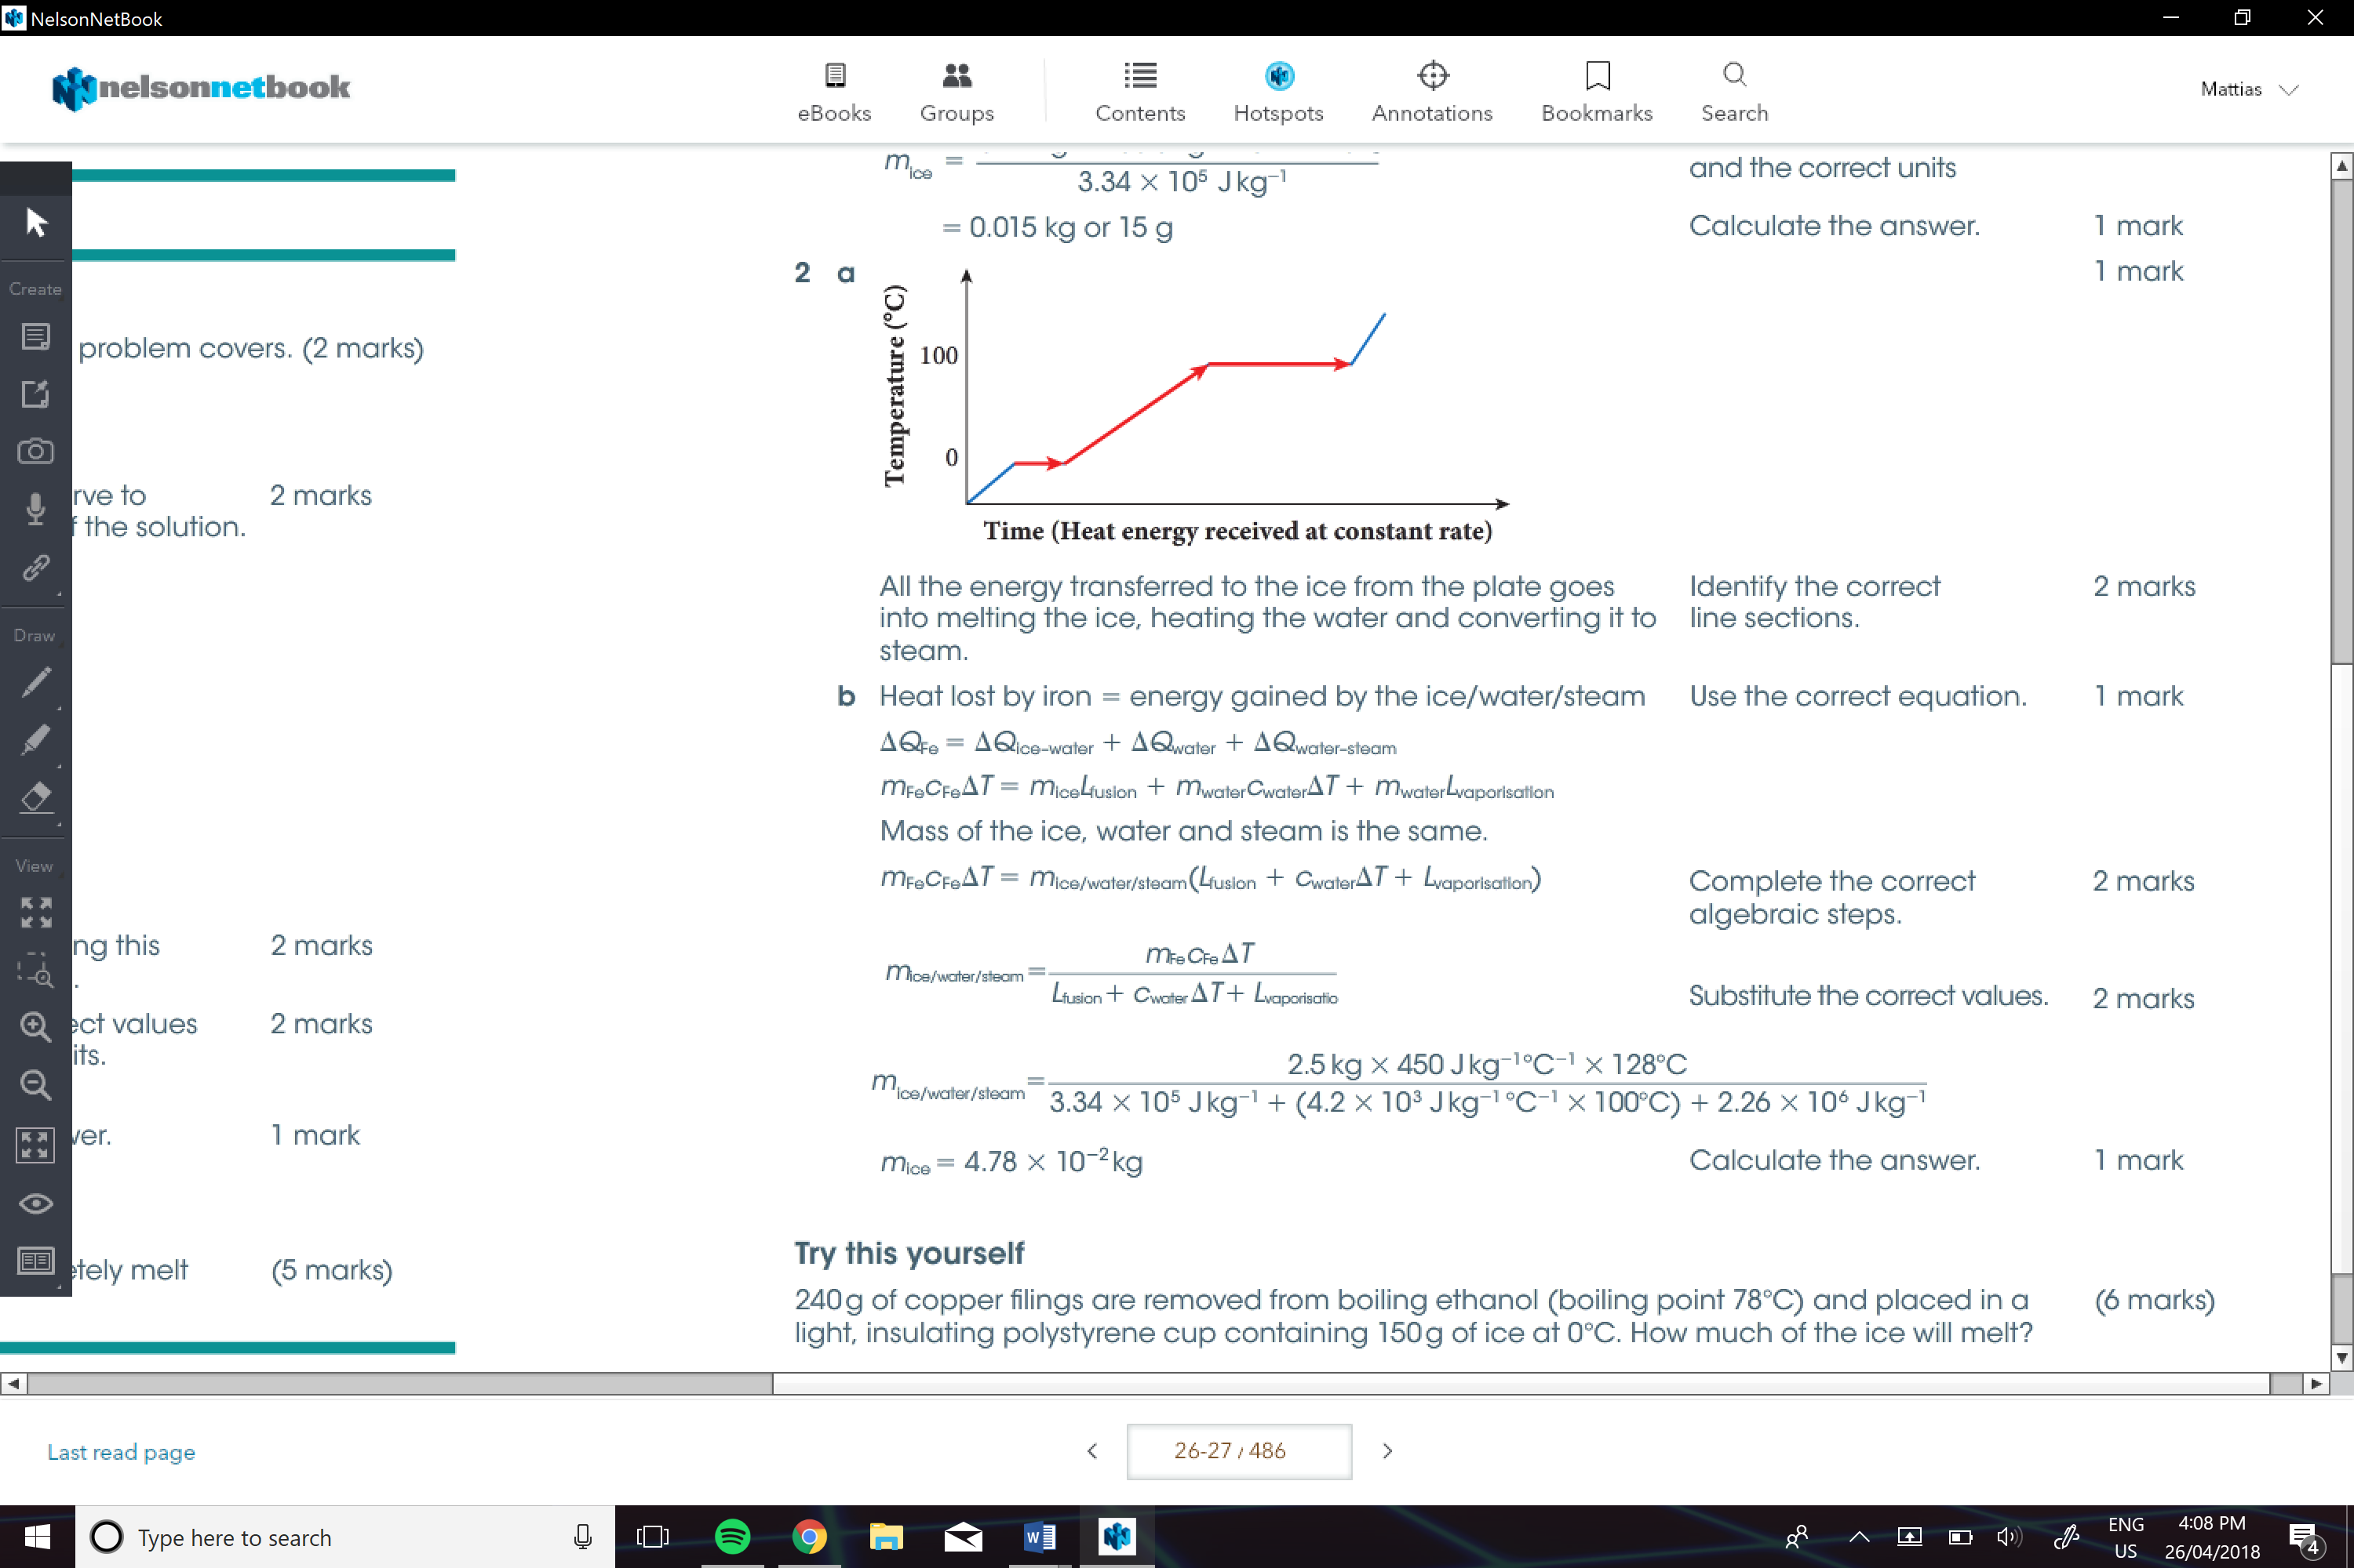

**Scientific Investigations:**

**Hypothesis:**

Is a tentative explanation or prediction not yet confirmed by an experiment.

-e.g. “The height attained by a water rocket will increase with the amount of water attained in the rocket”.

-make sure you include you independent and dependent variables.

- is your hypothesis is true due to an experiment, you state that the experiment supports your hypothesis.

**Estimating Uncertainties:**

Sources include:

* Limit of reading of measuring device
* Precision of measuring device
* Variation of the measurand

**Limit of Reading:**

For analogue It is half the smallest division on the scale.

-e.g. For a liquid in a glass thermometer with a scale marked in degrees Celsius , the limit of reading is 0.5oC

For digital has a uncertainty of a whole division.

-e.g. For a digital thermometer that reads whole degrees has a uncertainty of 1oC

**Conclusion**

Is a *very* brief summary of the results and their implications. Say what you found out and what it means. A conclusion should be a few sentences long.